Worksheet - 1

Q-1. Important Pages on CodeChef

Ans:

#include <iostream>

#include<bits/stdc++.h>

using namespace std;

int main() {

// your code goes here

int a,b;

cin>>a>>b;

if(a & !b) cout<<"https://www.codechef.com/contests"<<endl;

else if(!a) cout<<"https://www.codechef.com/practice"<<endl;

else cout<<"https://discuss.codechef.com"<<endl;

return 0;

}

Output:

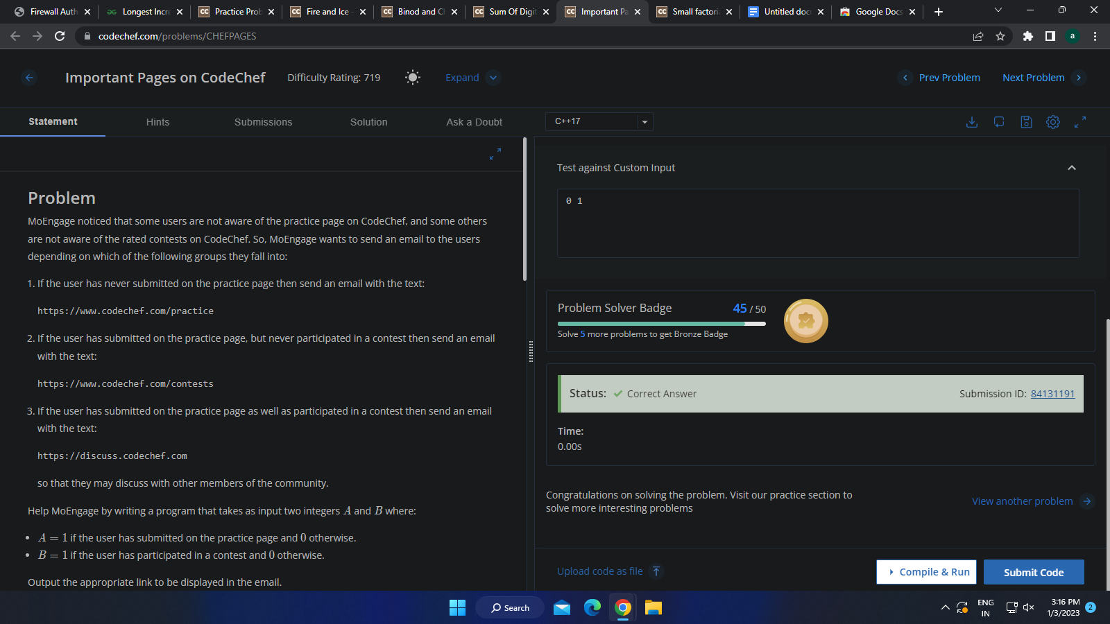

Q:- 15 Small factorials.

Ans:

#include <bits/stdc++.h>

#include <boost/multiprecision/cpp_int.hpp>

#include <iostream>

using namespace std;

using namespace boost::multiprecision;

int main() {

// your code goes here

int t;

cin>>t;

// Iterative approach

while(t--)

{

int n;

cin>>n;

cpp_int fact=1;

for(int i=n;i>0;i--)

fact=fact*i;

cout<<fact<<endl;

}

return 0;

}

// recursive approach

Int findFactorial(int n){

if(n<=1) return 1;

Return n*findFactorial(n-1);

}

Output:

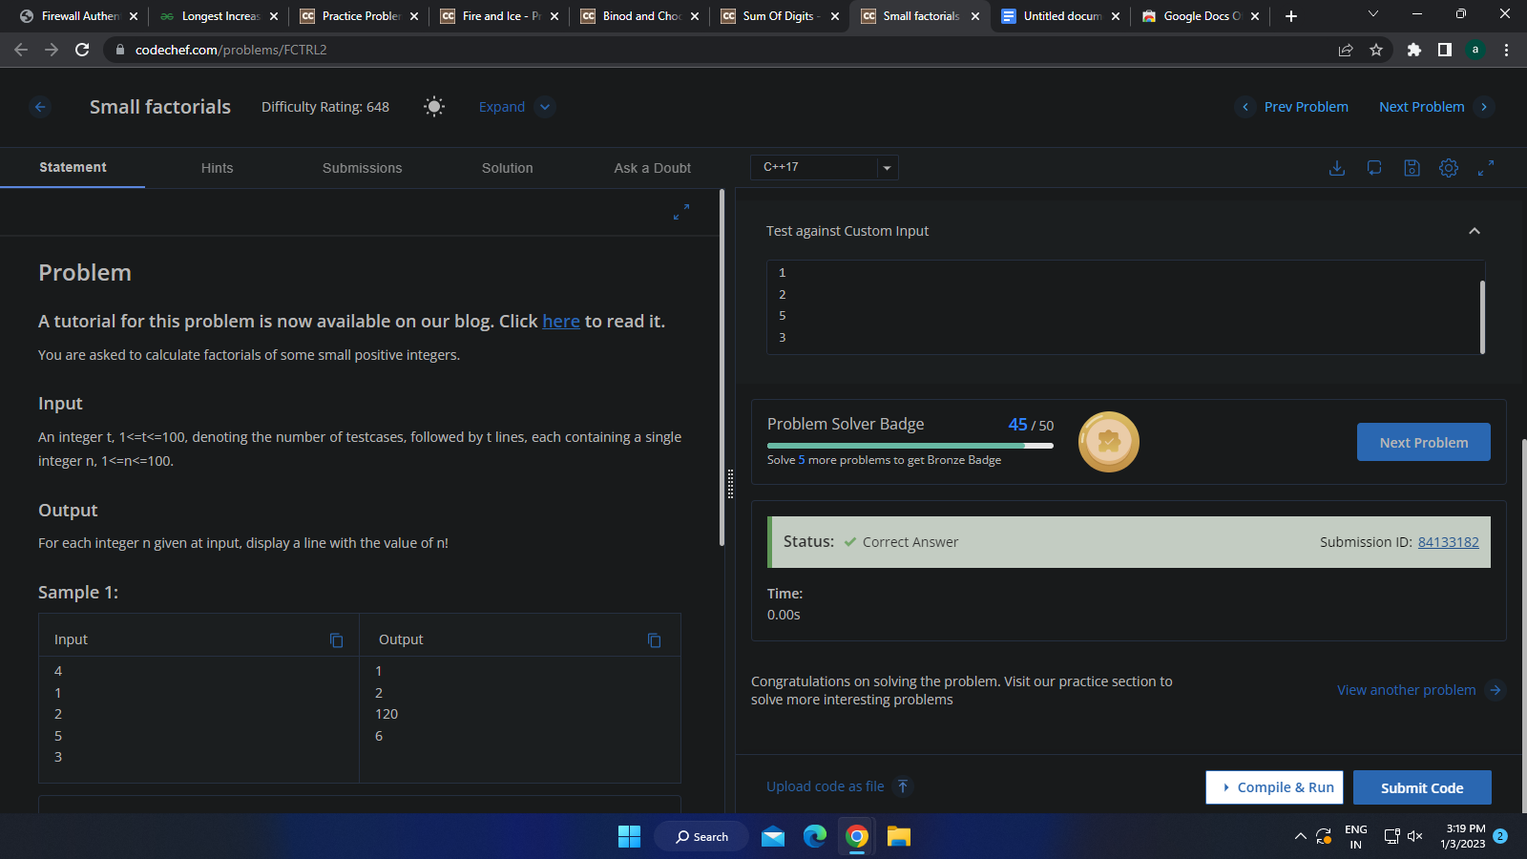

Q:- 16- Sum Of Digits

Ans;-

#include <iostream>

using namespace std;

int main() {

// your code goes here

int t;

cin>>t;

while(t--){

int num;

cin>>num;

int sum=0;

while(num){

int rem=num%10;

sum+=rem;

num=num/10;

}

cout<<sum<<endl;

}

return 0;

}

Output:-

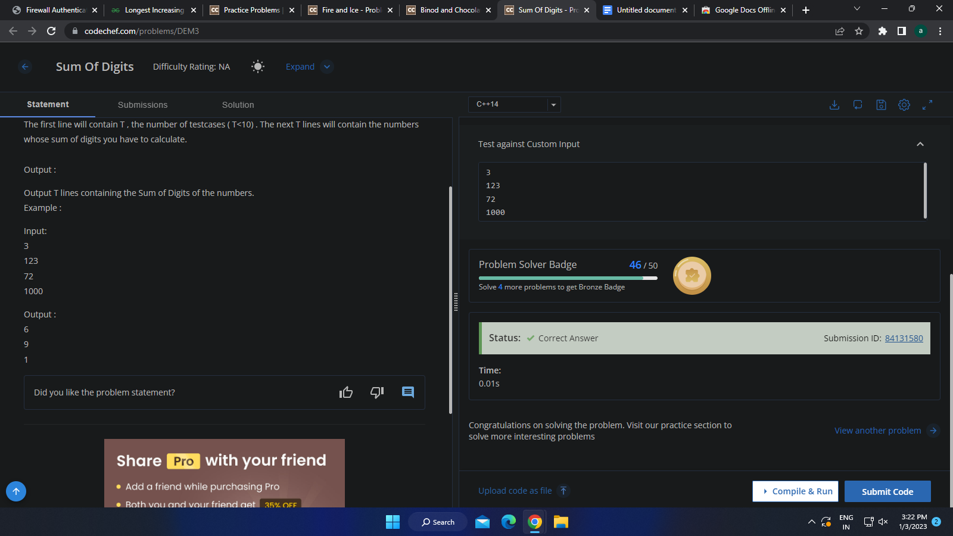

Q-4 Binod and Chocolates

Ans:-

#include <iostream>

#include<bits/stdc++.h>

using namespace std;

int main() {

// your code goes here

int t;

cin>>t;

while(t--){

int a, b;

cin>>a>>b;

if(a%3==0 || b%3==0 || (a+b)%3==0) cout<<"YES"<<endl;

else cout<<"NO"<<endl;

}

return 0;

}

Output:

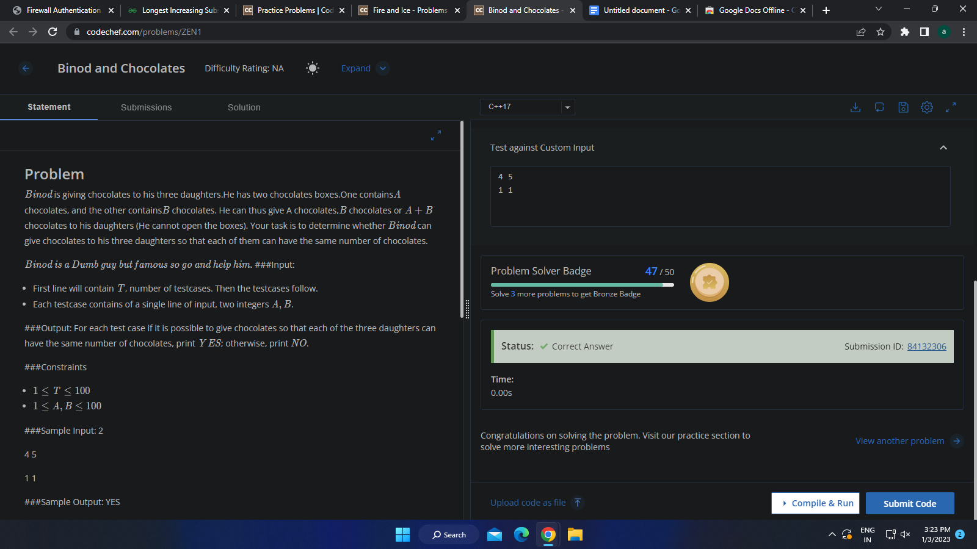

Q-6. Gold Mining

#include <iostream>

#include<bits/stdc++.h>

using namespace std;

int main() {

// your code goes here

int t;

cin>>t;

while(t--){

int n, x, y;

cin>>n>>x>>y;

if((n+1)*y>=x) cout<<"YES"<<endl;

else cout<<"NO"<<endl;

}

return 0;

}

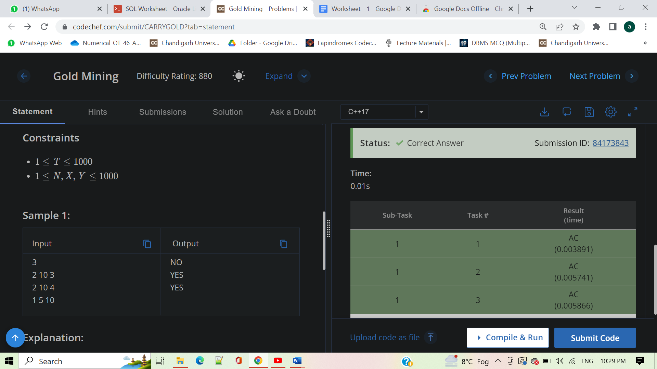

Q: - 8. Chef and the Wildcard Matching

#include <iostream>

#include<bits/stdc++.h>

using namespace std;

int main() {

// your code goes here

int t;

cin>>t;

while(t--){

string x, y;

cin>>x>>y;

bool flag=false;

for(int i=0;i<x.size();i++){

if(flag) exit;

if(x[i]=='?' || y[i]=='?') continue;

if(x[i]!=y[i]) flag=true;

}

if(flag) cout<<"No"<<endl;

else cout<<"Yes"<<endl;

}

return 0;

}

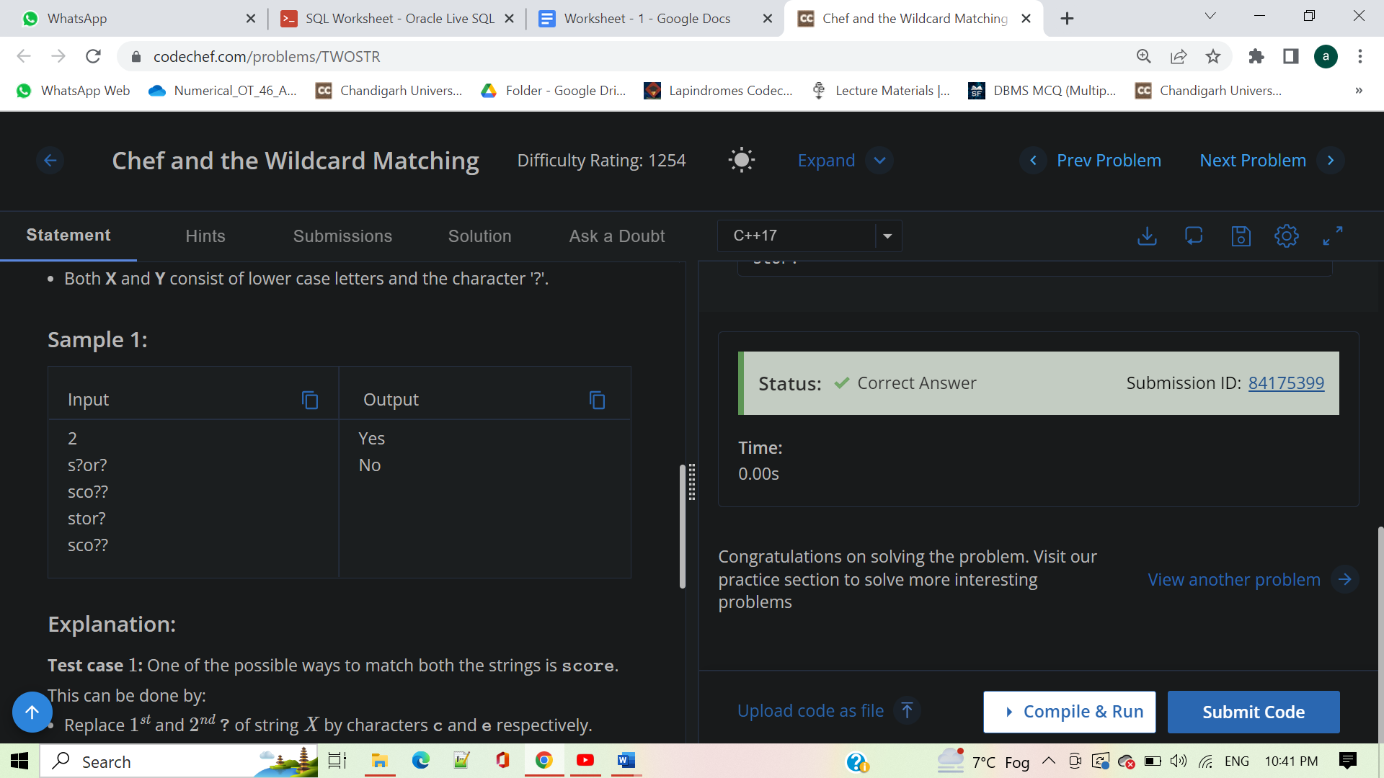

Q:7 - Chef on Vacation

#include <iostream>

#include<bits/stdc++.h>

using namespace std;

int main() {

// your code goes here

int t;

cin>>t;

while(t--){

int x,y,z;

cin>>x>>y>>z;

if((x+y)<=z) cout<<"YES"<<endl;

else cout<<"NO"<<endl;

}

return 0;

}

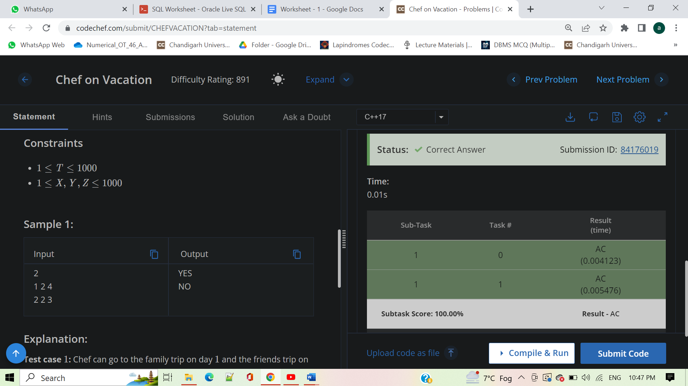

Q: - 5 . Special Fibonacci

#include <iostream>

#include<bits/stdc++.h>

using namespace std;

int main() {

// your code goes here

int t;

cin>>t;

while(t--){

int a, b, n;

cin>>a>>b>>n;

int ans=0;

n=n%3;

if(n==0) ans=a;

else if(n==1) ans=b;

else

ans=a^b;

cout<<ans<<endl;

}

return 0;

}

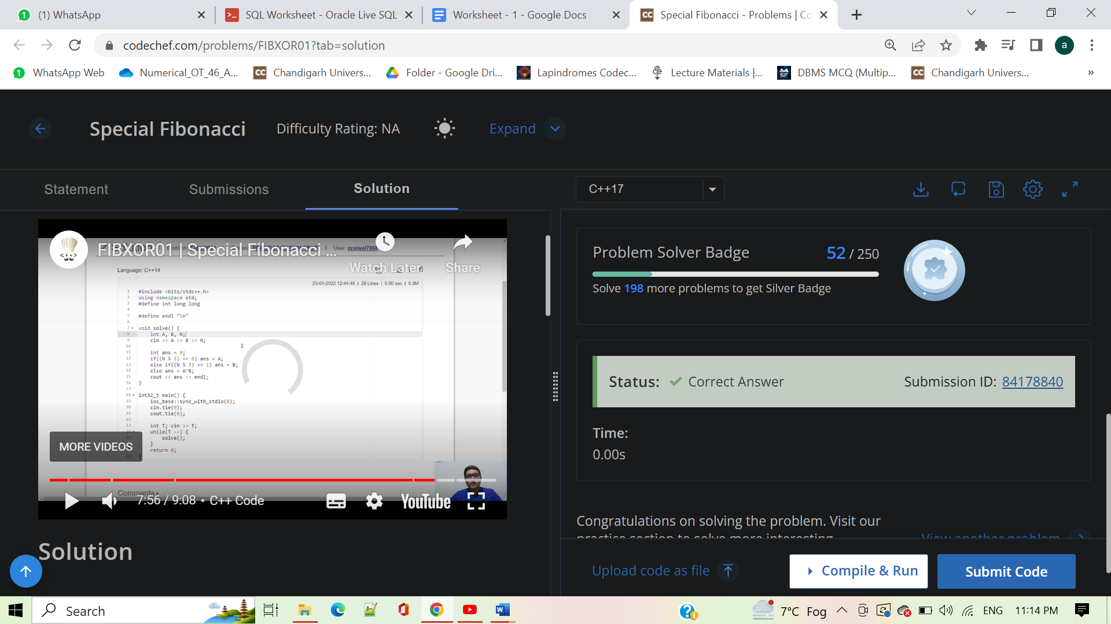

Q:-Janmansh and Games

#include <iostream>

#include<bits/stdc++.h>

using namespace std;

int main() {

// your code goes here

int t;

cin>>t;

while(t--){

int x,y;

cin>>x>>y;

if((x+y)%2) cout<<"jay"<<endl;

else cout<<"janmansh"<<endl;

}

return 0;

}

